National Textile University, Faisalabad
Department of Computer Science
Machine Learning: AIC-3072
Reading Notes in addition to Slides
Week 7
🎯 1. What is Linear Regression?
Linear Regression is a supervised learning algorithm used to predict a continuous numeric value (like salary, temperature, house price, etc.) based on one or more input variables.
It assumes there’s a linear relationship between the input(s) and the output.

🧮 Simple Linear Regression Formula
$$y=mx+c$$
Where:
- y = predicted output (dependent variable)
- x = input (independent variable)
- m = slope (how much y changes when x changes)
- c = intercept (value of y when x = 0)

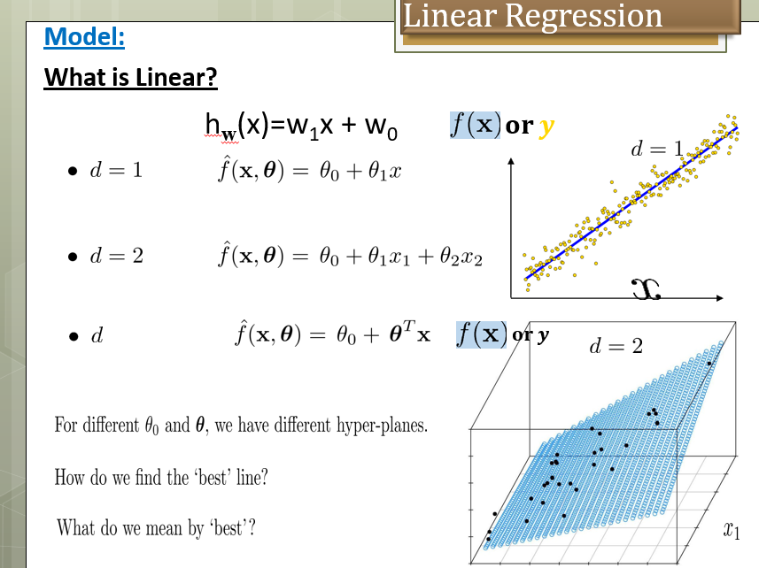

💡 Real-World Example
Hours Studied | Exam Score
1 | 35
2 | 40
3 | 50
4 | 55
5 | 60
6 | 65
👉 Goal: Predict Exam Score based on Hours Studied.
As the hours studied increase, the exam score also increases — that’s a linear pattern.

⚙️ 2. Python Implementation
Let’s write and explain code step by step 👇
# Import libraries
import pandas as pd
import numpy as np
import matplotlib.pyplot as plt
from sklearn.linear_model import LinearRegression

# Step 1: Create dataset
data = {'Hours':[1,2,3,4,5,6], 'Score':[35,40,50,55,60,65]}
df = pd.DataFrame(data)

# Step 2: Prepare data
X = df[['Hours']] # independent variable (2D array)
y = df['Score'] # dependent variable

# Step 3: Train model
model = LinearRegression()
model.fit(X, y)

# Step 4: Predict new value
predicted = model.predict([[7]])
print("Predicted Score for 7 hours study:", predicted[0])

# Step 5: Plot result
plt.scatter(df['Hours'], df['Score'], color='blue', label='Data points')
plt.plot(df['Hours'], model.predict(X), color='red', label='Best fit line')
plt.xlabel('Hours Studied')
plt.ylabel('Exam Score')
plt.legend()
plt.show()

🧾 Expected Output
Predicted Score for 7 hours study: ≈ 70
📈 The graph will show:
- Blue dots → actual data points
- Red line → best fit regression line

🔍 3. Equation of the Line
You can view the learned equation:
print("Slope (m):", model.coef_[0])
print("Intercept (c):", model.intercept_)
Example output:
Slope (m): 6.1
Intercept (c): 30.2
So the equation is:
$$Score=6.1×Hours+30.2$$

🔢 4. Multiple Linear Regression
If there are two or more input variables, it becomes Multiple Linear Regression.
Example: Predict House Price based on:
- Area (sq ft)
- Number of bedrooms
- Age of house
$$Price=m_{1}×Area+m_{2}×Bedrooms+m_{3}×Age+c$$
Python example:
from sklearn.linear_model import LinearRegression

X = [[2000, 3, 10],
[1800, 2, 15],
[2500, 4, 5],
[1500, 2, 20]]
y = [500000, 400000, 650000, 350000]

model = LinearRegression()
model.fit(X, y)

print("Predicted Price for 2300 sq ft, 3 bed, 8 years old:", model.predict([[2300, 3, 8]]))

🧠 5. Evaluation Metrics
To check how good the model is, we use:
- Mean Squared Error (MSE)
- R² Score (Coefficient of Determination)
from sklearn.metrics import mean_squared_error, r2_score

y_pred = model.predict(X)
print("MSE:", mean_squared_error(y, y_pred))
print("R² Score:", r2_score(y, y_pred))
✅ R² close to 1.0 means the model fits well.

⚖️ 6. Limitations
- Assumes linear relationship (not good for curved data).
- Sensitive to outliers.
- Doesn’t handle categorical (text) data directly.

Concept | Meaning
x is scalar | Only one input feature per record
x is vector | Multiple input features per record
y is scalar | Predicting one output value
y is vector | Predicting multiple outputs at once

🧠 1. Regression Overview
In regression problems, we predict output(s) y from input(s) x.
Both x and y can be:
- A scalar (single value)
- Or a vector (multiple values)
Let’s see the four possible cases:

🟢 Case 1: One-variable Regression
👉 y is a scalar
📘 Meaning:
We predict one output value (scalar y).
Example: Predict Salary from Experience.
$$y=mx+c$$
import numpy as np
from sklearn.linear_model import LinearRegression
import matplotlib.pyplot as plt

# Training data
X = np.array([[1], [2], [3], [4], [5]]) # Experience (years)
y = np.array([30000, 35000, 40000, 45000, 50000]) # Salary

# Model
model = LinearRegression()
model.fit(X, y)

# Prediction
pred = model.predict([[6]])
print("Predicted Salary for 6 years experience:", pred[0])

# Plot
plt.scatter(X, y, color='blue')
plt.plot(X, model.predict(X), color='red')
plt.xlabel('Experience (years)')
plt.ylabel('Salary')
plt.title('One-variable Regression (y is scalar)')
plt.show()
✅ Explanation:
- x is a single number (years of experience).
- y is a single number (salary).
- So both are scalars — the simplest regression form.

🟣 Case 2: Multi-variable Regression
👉 y is a vector
📘 Meaning:
We predict multiple outputs at once.
Example: Predict both Math score and Science score from Study Hours.
$$[\begin{aligned}y_{1} \\ y_{2}\end{aligned}]=mx+c$$
# Input: Study hours
X = np.array([[1], [2], [3], [4], [5]])

# Output: [Math score, Science score]
y = np.array([
[35, 40],
[45, 48],
[50, 55],
[60, 65],
[70, 75]
])

model = LinearRegression()
model.fit(X, y)

# Predict both scores for 6 hours of study
pred = model.predict([[6]])
print("Predicted Math & Science Scores for 6 hours:", pred[0])
✅ Explanation:
- Input x = single value (hours studied).
- Output y = vector of two values (math & science scores).
- So it’s multi-output regression (also called multi-target regression).

🔵 Case 3: Single-feature Regression
👉 x is a scalar
📘 Meaning:
Each sample has only one feature (like height or hours studied).
We’ve already seen this in Case 1 — that’s the standard simple linear regression.

🟠 Case 4: Multiple-feature Regression
👉 x is a vector
📘 Meaning:
We predict one output (y) based on several input features.
Example: Predict House Price from Area, Bedrooms, Age.
$$y=m_{1}x_{1}+m_{2}x_{2}+m_{3}x_{3}+c$$
# Input: [Area (sq ft), Bedrooms, Age]
X = np.array([
[2000, 3, 10],
[1800, 2, 15],
[2500, 4, 5],
[1500, 2, 20]
])

# Output: House Price
y = np.array([500000, 400000, 650000, 350000])

model = LinearRegression()
model.fit(X, y)

# Predict new house price
new_house = np.array([[2300, 3, 8]])
pred = model.predict(new_house)
print("Predicted Price:", pred[0])
✅ Explanation:
- Input x = vector of features (area, bedrooms, age).
- Output y = scalar (price).
- So this is multiple-feature regression (also called multiple linear regression).

📊 Summary Table
Case | Name | x (input) | y (output) | Example
1 | One-variable regression | Scalar | Scalar | Predict salary from experience
2 | Multi-variable regression | Scalar | Vector | Predict math & science marks from hours
3 | Single-feature regression | Scalar | Scalar | Same as Case 1
4 | Multiple-feature regression | Vector | Scalar | Predict house price from multiple factors

🎯 1. What is a Loss Function?
A loss function (also called cost function) tells us how wrong our model’s predictions are.
In linear regression, our goal is to:
Find the line (or plane) that minimizes the total prediction error.

🧮 Equation of a Linear Regression Line
$$\hat{y}=mx+c$$
Where:
- $\hat{y}$= predicted value
- $y$= actual value
- $x$= input
- $m$= slope
- $c$= intercept
We want to find m and c so that $\hat{y}$is as close as possible to $y$for all data points.

⚖️ 2. Mean Squared Error (MSE) – the Loss Function
In Linear Regression, the most common loss function is the Mean Squared Error (MSE).
$$J(m,c)=\frac{1}{n}\sum_{i=1}^{n}{}(y_{i}-\hat{y_{i}})^{2}$$
Where:
- $n$= number of data points
- $y_{i}$= actual value
- $\hat{y_{i}}$= predicted value

💡 In Simple Words:
- Find the difference between actual and predicted values → (error)
- Square the difference (to remove negative signs)
- Average all those squared errors
So, MSE tells us how far off the predictions are — the smaller, the better.

📉 3. Why "Square" the Errors?
- Squaring makes all errors positive
- Larger errors are penalized more
- It gives a smooth, continuous function for optimization

🧠 4. How the Model Learns
The algorithm tries to find m and c that make the MSE as small as possible.
This is done using Gradient Descent:
- Start with random values of m and c
- Gradually adjust them in the direction that reduces the loss
- Stop when the loss cannot decrease further

🧪 5. Python Example
import numpy as np
import matplotlib.pyplot as plt
from sklearn.linear_model import LinearRegression
from sklearn.metrics import mean_squared_error

# Dataset: Hours studied vs. Marks
X = np.array([[1], [2], [3], [4], [5]])
y = np.array([30, 40, 50, 60, 70])

# Train model
model = LinearRegression()
model.fit(X, y)

# Predictions
y_pred = model.predict(X)

# Calculate Loss (Mean Squared Error)
mse = mean_squared_error(y, y_pred)
print("Mean Squared Error (Loss):", mse)

# Plot
plt.scatter(X, y, color='blue', label='Actual')
plt.plot(X, y_pred, color='red', label='Predicted')
plt.xlabel('Hours Studied')
plt.ylabel('Marks')
plt.legend()
plt.title('Linear Regression and Loss Function (MSE)')
plt.show()

🧾 Output Example:
Mean Squared Error (Loss): 0.0
If the line fits perfectly, MSE = 0.
Otherwise, the higher the MSE, the worse the fit.

🔍 6. Visualizing the Loss Function
Imagine plotting Loss vs. slope (m) or Loss vs. intercept (c).
It looks like a bowl-shaped curve (a convex function):
.
. .
. .
. .
-----.-----------.-----
High Min High
Loss Loss Loss
At the bottom of the bowl, the loss is minimum — that’s the best-fit line.

🧩 7. Other Loss Functions (less common in Linear Regression)
Loss Function | Formula | Use Case
Mean Absolute Error (MAE) | (1/n) Σ | y - ŷ
Huber Loss | Combines MSE + MAE | Balanced loss for robustness
Log-Cosh Loss | log(cosh(y - ŷ)) | Smooth, robust alternative

🧾 8. In Summary
Term | Meaning
Loss Function | Measures how wrong predictions are
MSE | Average of squared prediction errors
Goal | Find m, c that minimize loss
Optimization | Gradient descent used to reach lowest loss

✅ In simple words:
The Loss Function in Linear Regression is like a "score" that tells how bad your line is.
The algorithm keeps adjusting the line until that score (error) is as low as possible.

